**Task 1: MONGODB CONTINUE :**

Pending done in day 12

db.laptops.find({name:"Dell",price:{$gt:30000 , $lt:50000}})

**TASK 2:**

**CREATE DATABASE BANK INSIDE CREATE COLLECTIONS AS**

**1) CustomerAccount**

**2) CustomerPersonal**

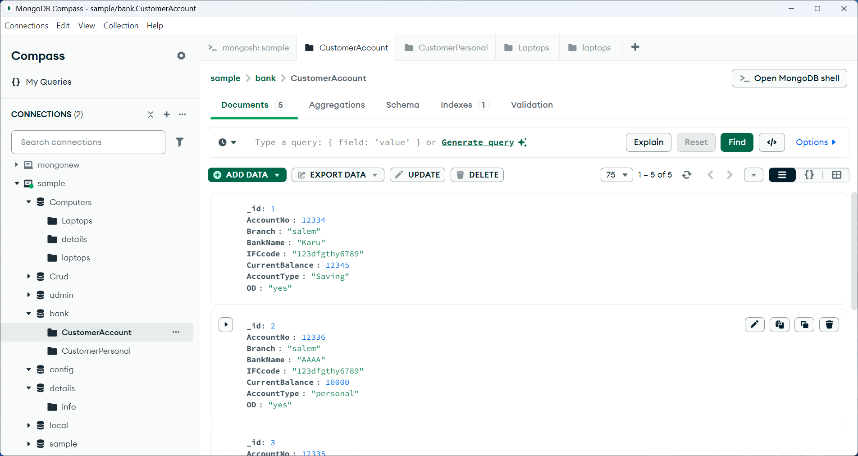

**FOR** **CustomerAccount**

**FOR** **CustomerPersonal**

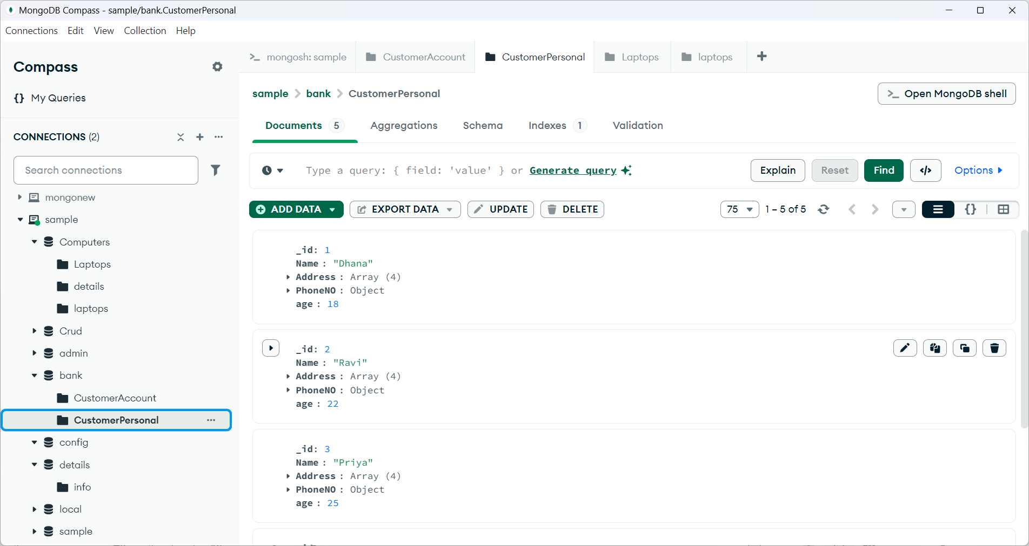

Some questions that are in written notes:

Answers are:

**query1 :**

db.customerAccount.aggregate([

{

$match: { overDraft: "yes" }

},

{

$lookup: {

from: "customerPersonal",

localField: "_id",

foreignField: "_id",

as: "customerDetails"}})]

**query 2:**

db.customerPersonal.aggregate([

{

$lookup: {

from: "customerAccount",

localField: "_id",

foreignField: "_id",

as: "account_details"

}

},

{

$match: {

"account_details.branch": { $in: ["kinathukadavu", "coimbatore"] }

}

},

{

$project: {

name: 1,

address: 1,

"account_details.branch": 1

}

}

])

**query 3:**

db.customerAccount.aggregate([

{

$match: {

currentBalance: { $gte: 10000, $lte: 20000 }

}

},

{

$lookup: {

from: "customerPersonal",

localField: "_id",

foreignField: "_id",

as: "personal_details"

}

},

{

$project: {

phoneNo: "$personal_details.phoneNo"

}

}

])

**query 4:**

db.customerAccount.aggregate([

{

$match: {

accountType: "savings"

}

},

{

$lookup: {

from: "customerPersonal",

localField: "_id",

foreignField: "_id",

as: "personal_details"

}

},

{

$project: {

"personal_details._id": 1,

"personal_details.name": 1,

"personal_details.address": 1,

"personal_details.phoneNo": 1,

"personal_details.age": 1

}

}

])

**query 5:**

db.customerPersonal.aggregate([

{

$lookup: {

from: "customerAccount",

localField: "_id",

foreignField: "_id",

as: "account_details"

}

},

{

$addFields: {

status: {

$cond: {

if: { $eq: [{ $arrayElemAt: ["$account_details.ifscCode", 0] }, "abc123"] },

then: "same",

else: "unique"

}

}

}

},

{

$project: {

_id: 1,

name: 1,

address: 1,

phoneNo: 1,

age: 1,

status: 1

}

}

])